|  |  |
| --- | --- |
| Online education  IT PAT 2022 | By Rohern Dhaya 12U |

Contents

Topic and Scope 2

User Requirements 3

Navigation - Flow chart 0

GUI – Design 0

Data Dictionary 7

Database 7

Text files 7

Classes and objects 7

Other data structures 7

IPO Table 8

# Topic and Scope

School is a big part of almost everyone’s life and being educated is extremely important if you want to be successful and a useful member of society however many people often lack the drive or motivation to study. We aim to solve this problem. EduPro is an online app which allows students to organize and store all their textbooks digitally, create their own custom study plan and manage upcoming assessments. You can also set reminders, register to different online services and will provide links to other useful resources. As a teacher you will be able to manage which textbooks learners can access, post notices that are relevant to students, give out assessment dates etc. In short EduPro includes all the information a student would need at the touch of a button, including News, Calendar events, Homework, useful Resources, Gallery and Contact lists.

# User Requirements

|  |  |  |
| --- | --- | --- |
| **User Requirements** | | |
| **Users** | **Student** | **Teacher** |
| **User needs** | Student will be able to:   * Manage their textbooks effectively * Create a suitable study time table * Check notices * Check upcoming assignments * Set custom reminders | Teacher will be able to:   * Post notices * Make changes to upcoming test dates * Add new test dates * Manage what textbooks learners have access to. |
| **Acceptable limitations** | * Learner won’t be able to edit textbooks * Learner won’t be able to edit test dates * Learner is limited to the provided calendar for study planning * Learner can only set a limited number of reminders at a time. | * Teachers have no access to learners’ study time tables * Teachers have no access to learners’ reminders |
| **Processing requirements** | 64-bit Architecture  Minimum system memory: 4 GB  Minimum available hard drive space: 10 GB  Minimum CPU architecture: 4 cores  Operating System (64-bit only)   * Windows 7 Requires Service Pack 1 and Microsoft updates KB2533623 and KB3033929 * Windows 8 * Windows 8.1 * Windows 10 * Windows 2008 R2 * Windows 2012 / 2012 R2 * Windows 2016   Windows Installer - 4.5 or higher | 64-bit Architecture  Minimum system memory: 4 GB  Minimum available hard drive space: 10 GB  Minimum CPU architecture: 4 cores  Operating System (64-bit only)   * Windows 7 Requires Service Pack 1 and Microsoft updates KB2533623 and KB3033929 * Windows 8 * Windows 8.1 * Windows 10 * Windows 2008 R2 * Windows 2012 / 2012 R2 * Windows 2016 * Windows Installer - 4.5 or higher |

# Navigation - Flow chart

# GUI – Design



Form - Welcome screen

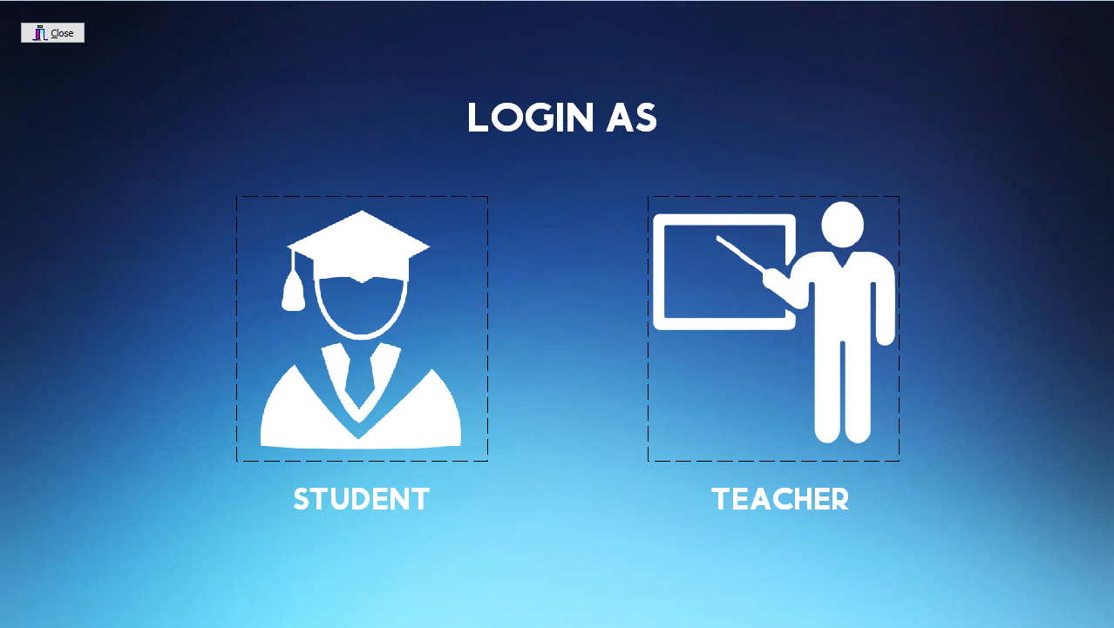

Form - Home screen

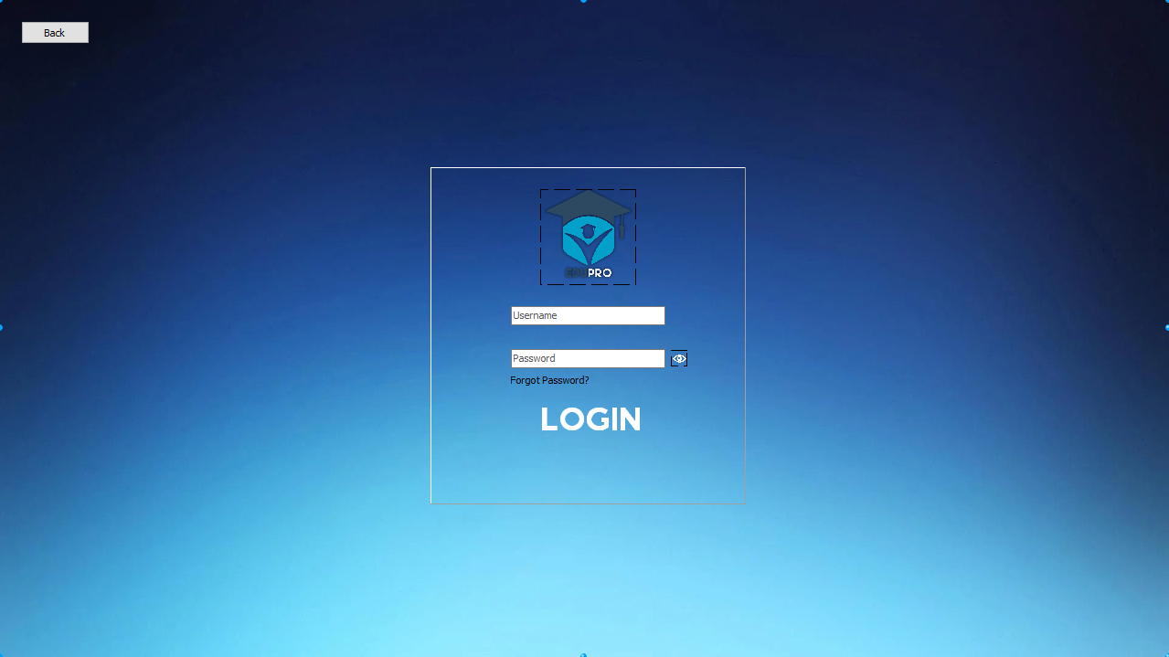

Form - Teacher login

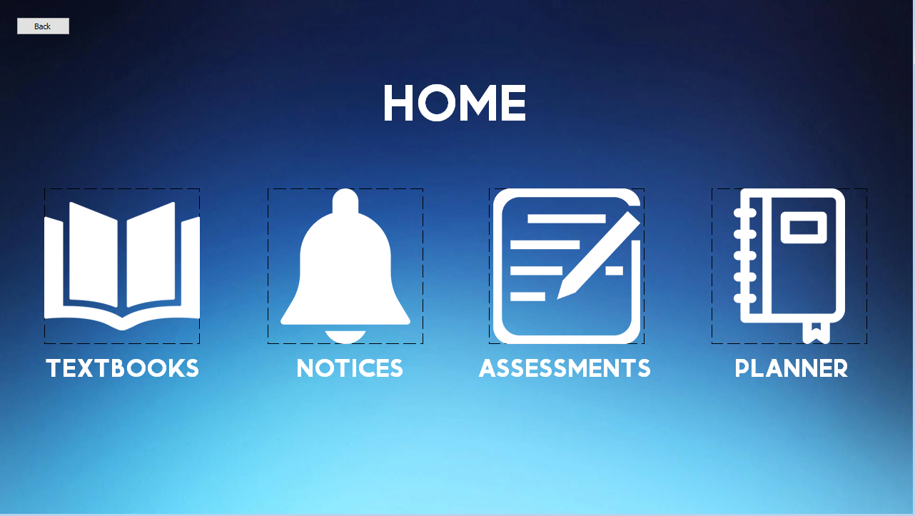

Form - Student Home

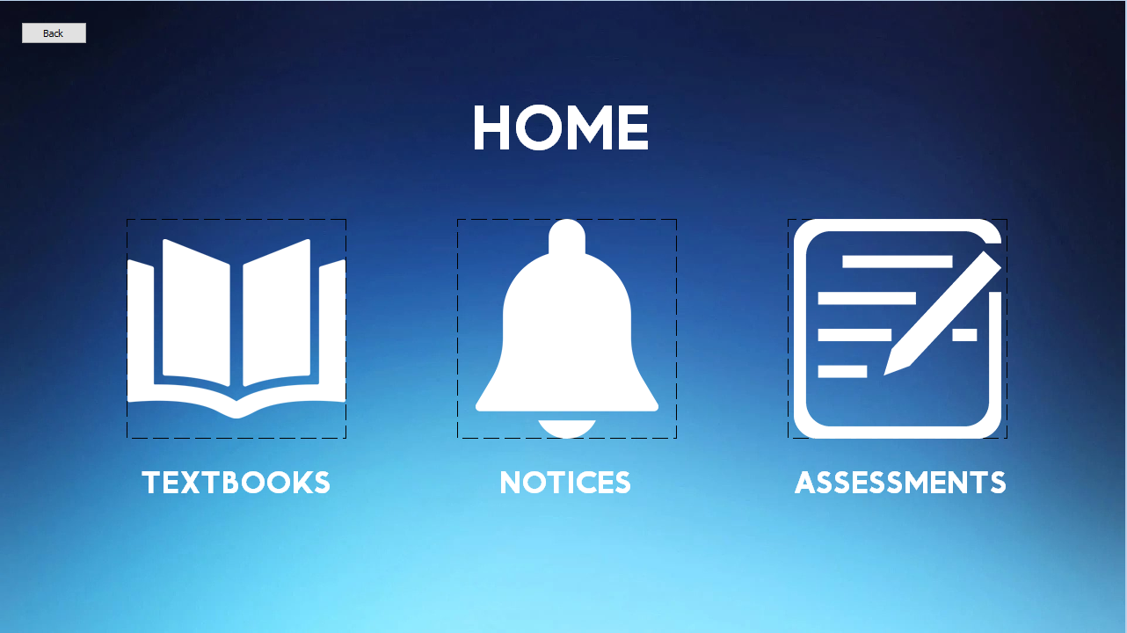

Form - Teacher Home

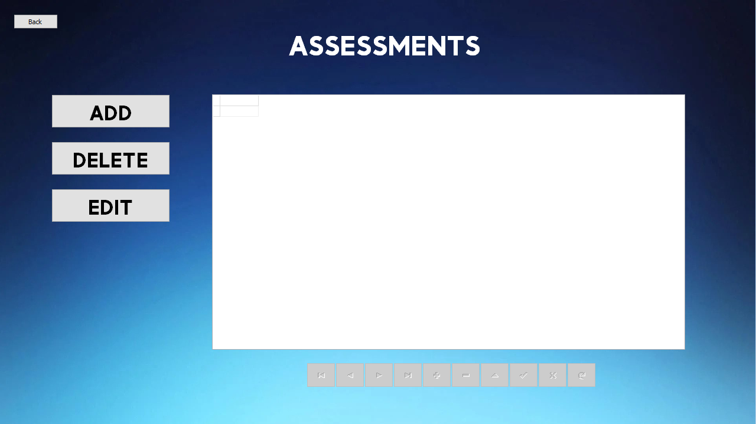

Form - Teacher Assessments

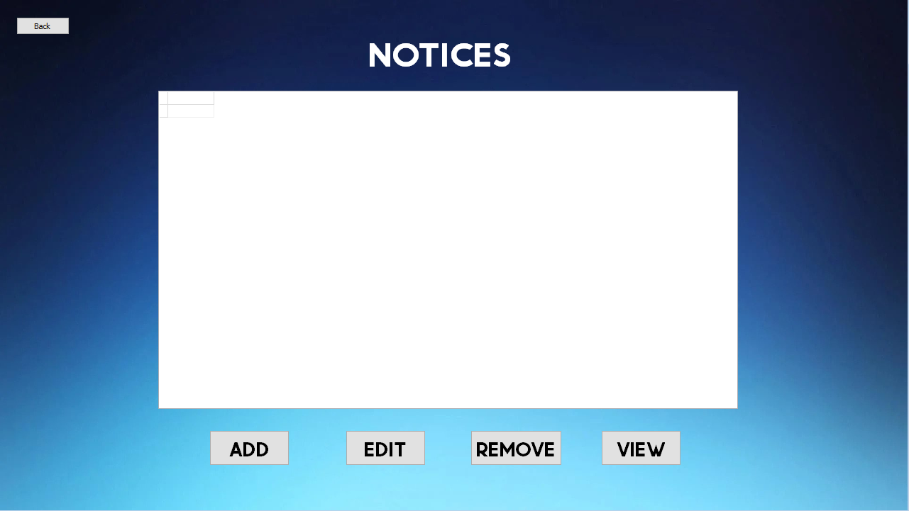

Form - Teacher notices

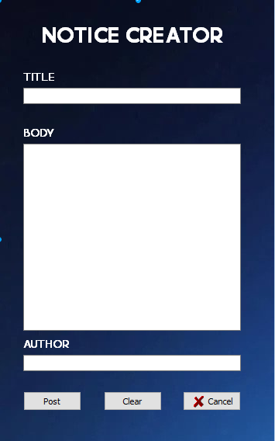

Form - Notice creator

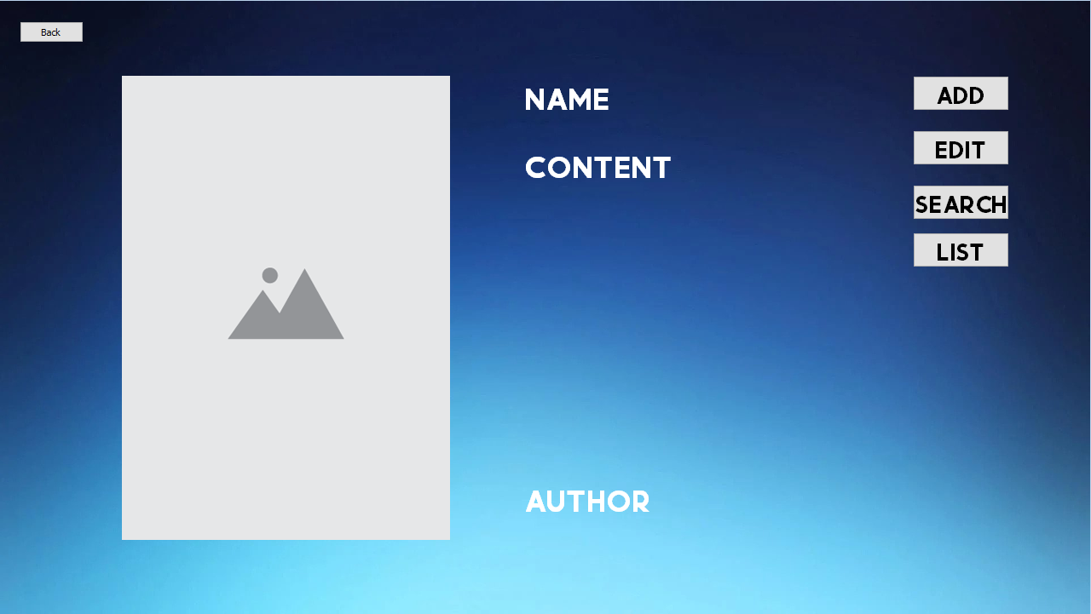

Form - Teacher textbooks

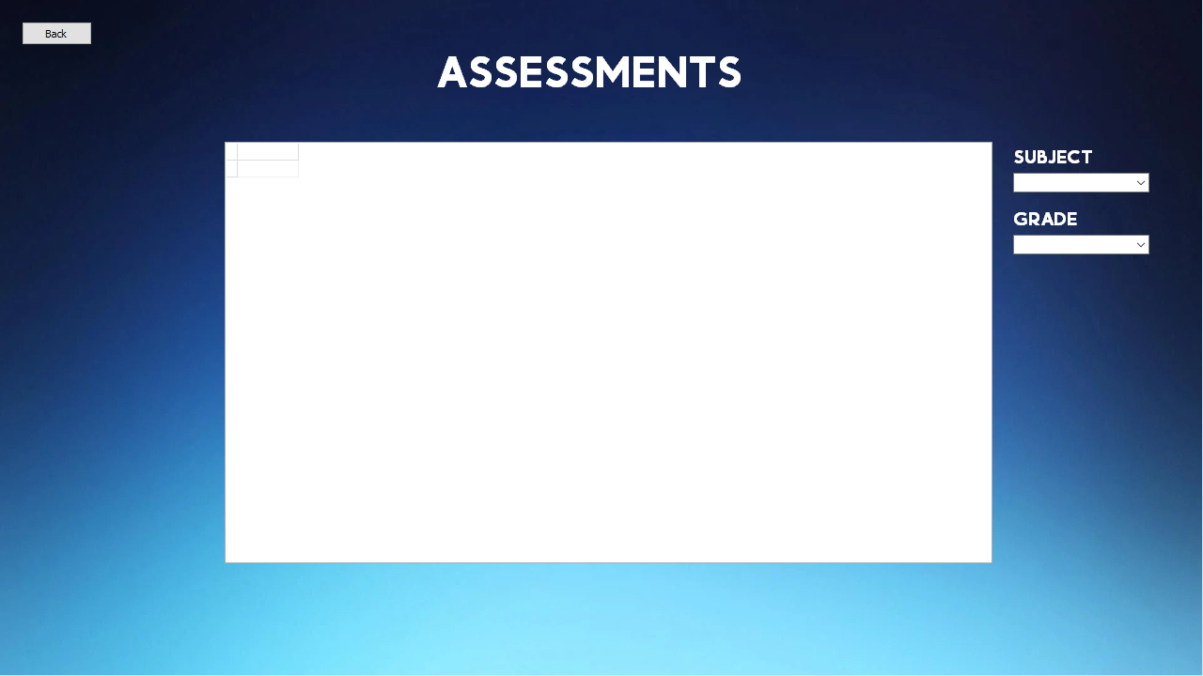

Form - Student Assessments

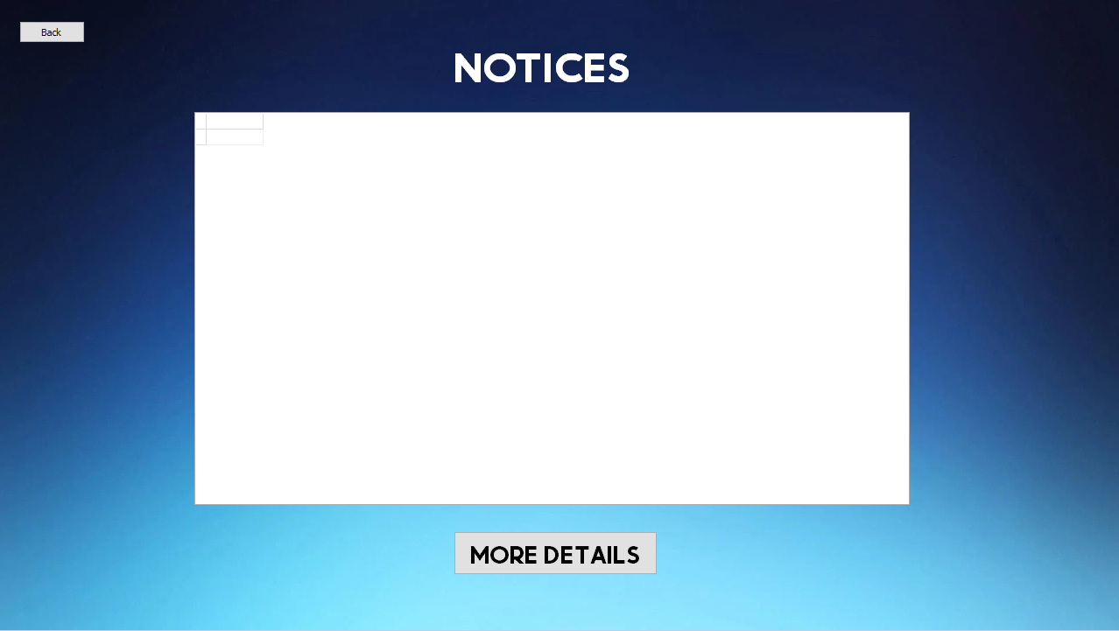

Form - Student Notices

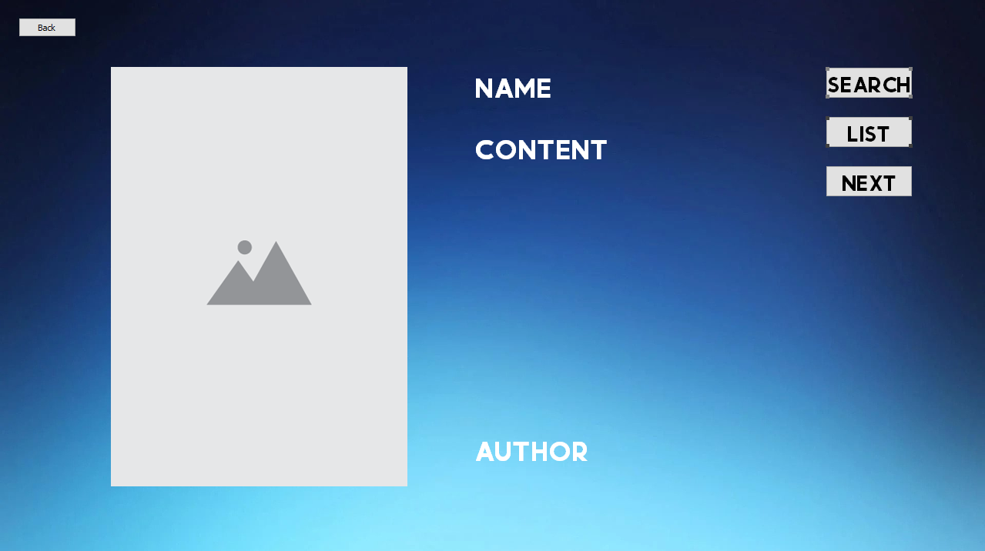

Form - Student Textbooks

# Data Dictionary

## Database

|  |  |  |  |
| --- | --- | --- | --- |
|  | **Field name** | **Data type** | **Field size** |
| PK | NoticeNo | AutoNumber | Long Integer |
|  | Heading | Short Text | 15 |
|  | Content | Short Text | 255 |
|  | Author | Short Text | 10 |

Table - Notices

|  |  |  |  |
| --- | --- | --- | --- |
|  | **Field name** | **Data type** | **Field size** |
| PK | PlannerID | AutoNumber | Long Integer |
|  | Date | Date/Time | N/A |
|  | Subject | Short Text | 10 |
|  | Paper | Short Text | 10 |
|  | Notes | Short Text | 50 |

Table - Planner

|  |  |  |  |
| --- | --- | --- | --- |
|  | **Field name** | **Data type** | **Field size** |
| PK | TextbookNo | AutoNumber | Long Integer |
|  | Name | Short Text | 20 |
|  | Publisher | Short Text | 15 |
|  | Thumbnail | Attachment | N/A |

Table - Textbooks

|  |  |  |  |
| --- | --- | --- | --- |
|  | **Field name** | **Data type** | **Field size** |
| PK | AssessmentNo | AutoNumber | Long Integer |
|  | Subject | Short Text | 15 |
|  | Paper | Short Text | 10 |
|  | Scope | Short Text | 50 |
|  | Date | Date/Time | N/A |
|  | Grade | Short Text | 2 |

Table - Upcoming Assessments

|  |  |  |  |
| --- | --- | --- | --- |
|  | **Field name** | **Data type** | **Field size** |
| PK | Username | Short Text | 25 |
|  | Password | Short Text | 30 |

Table - Login Details

|  |  |  |  |
| --- | --- | --- | --- |
|  | **Field name** | **Data type** | **Field size** |
| PK | TeacherID | AutoNumber | Long Integer |
|  | Name | Short Text | 15 |
|  | Surname | Short Text | 15 |
|  | Email | Short Text | 30 |
|  | Title | Short Text | 10 |

Table - Contact us

## Text files

I will be making use of text files to track who logged in and when and to track all the changes made to any databases.

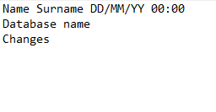

# IPO Table

|  |  |  |  |
| --- | --- | --- | --- |
| **Screens** | **Input** | **Process** | **Output** |
| ***Welcome screen*** | Source of input:   * Mouse click   Data type:   * N/A   Format of input:   * N/A   GUI component used:   * TImage   Errors   * N/A   Data to input   * N/A | Login screen form is displayed and the welcome screen is then hidden when the login button is clicked or user can bypass login by logging in as guest and use the kiosk in customer mode | Login form is displayed |
| ***Login screen*** | Source of input:   * Keyboard * Mouse click   Data type:   * String   Format of input:   * N/A   GUI component used:   * TImage * TEdit   Errors   * Message dialogue if login details are incorrect * Message dialogue if nothing is entered   Data to input   * Email * Password | User is required to enter their login details if correct they’ll be redirected to the home screen and the login screen will be hidden. If they are incorrect or they haven’t entered anything the appropriate message dialogue will be shown | Message dialogues for errors are displayed and the home screen form is displayed |
| ***Teacher home screen*** | Source of input:   * Mouse click   Data type:   * N/A   Format of input:   * N/A   GUI component used:   * TImage   Errors   * N/A   Data to input   * N/A | One of the main screens of the program. It is the gateway to all the other screens in the program.   1. User chooses which screen they would like to visit 2. That form will be displayed 3. Home screen form will be hidden | Chosen form is then displayed |
| ***Student home screen*** | Source of input:   * Mouse click   Data type:   * N/A   Format of input:   * N/A   GUI component used:   * TImage   Errors   * N/A   Data to input   * N/A | One of the main screens of the program. It is the gateway to all the other screens in the program.   1. User chooses which screen they would like to visit 2. That form will be displayed 3. Home screen form will be hidden | Chosen form is then displayed |
| ***Teacher assessments*** | Source of input:   * Mouse click * Keyboard   Data type:   * String * Date   Format of input:   * N/A   GUI component used:   * TButton * TDBGrid   Errors   * Message dialogue if nothing is selected   Data to input   * Subject of test * Paper of test * Grade * Date of test | User will have an option to add, delete or edit an existing field in the database regarding to the tests | Changes are saved onto the database then displayed on the form |
| ***Teacher notices*** | Source of input:   * Mouse click * Keyboard   Data type:   * Text * Date   Format of input:   * N/A   GUI component used:   * TDBGrid * TButton   Errors   * Message dialogue if nothing is selected   Data to input   * N/A | User will be presented with all notices currently in the database and will have an option to add, edit, view or remove a notice. They will be directed to the notice creator screen if they wish to add a notice | Changes to the database will be shown. Notice creator form will open |
| ***Notice creator*** | Source of input:   * Mouse click * Keyboard   Data type:   * String   Format of input:   * N/A   GUI component used:   * TEdit * TRichEdit   Errors   * Message dialogue if nothing is entered * Message dialogue if something is left out   Data to input   * Title * Body * Author | User will be presented with a notice creator screen where they will be able to create a notice and enter all the relevant details. The date and time will be automatically recorded when it is posted | The new notice will then be saved in the existing database and will be displayed on the form. |
| ***Teacher textbooks*** | Source of input:   * Mouse click   Data type:   * N/A   Format of input:   * N/A   GUI component used:   * TImage * TButton * TLabel   Errors   * N/A   Data to input   * N/A | User will be able to choose whether they want to add, edit, search or view the entire list of all the textbooks available on the database | Image, name, content and author will be displayed on the form |
| ***Student Assessments*** | Source of input:   * Mouse click   Data type:   * N/A   Format of input:   * N/A   GUI component used:   * TDBGrid * TComboBox   Errors   * N/A   Data to input   * N/A | Students will be able to view all the assessments on the database and filter them according to subject and grade | The filtered assessments will be displayed on the TDBGrid |
| ***Student Notices*** | Source of input:   * Mouse click   Data type:   * N/A   Format of input:   * N/A   GUI component used:   * TDBGrid * TButton   Errors   * N/A   Data to input   * N/A | Students will be able to view all notices on the database and open their selected notice to view it in detail | The selected notice will be opened on a separate panel |
| ***Student Textbooks*** | Source of input:   * Mouse click * Keyboard   Data type:   * String   Format of input:   * N/A   GUI component used:   * TImage * TButton * TLabel   Errors   * N/A   Data to input   * N/A | Students will be able to scroll through a list of textbooks, the price and where to buy them. They can also search through the entire database or view the entire list. | Image, name, content and author will be displayed on the form. |
| ***Student Planner*** | Source of input:   * Mouse click * Keyboard   Data type:   * String   Format of input:   * N/A   GUI component used:   * TCalendar * TButton   Errors   * N/A   Data to input   * N/A | The student will be abled to choose a date where they will be able to choose what subject they want to study on that day. When creating a study plan, they will be directed to a study plan creator. They can also choose to list all their plans and delete some of them. | Study plan creator will be opened and the created plan will then be saved on the data |
| ***Contact us*** | Source of input:   * Mouse click * Keyboard   Data type:   * String   Format of input:   * N/A   GUI component used:   * TDBGrid * TButton   Errors   * N/A   Data to input   * N/A | User will be presented with all the contact details of staff members, if user is a teacher, they will be able to edit the database. | Changes made to database will be saved and outputted onto the form |